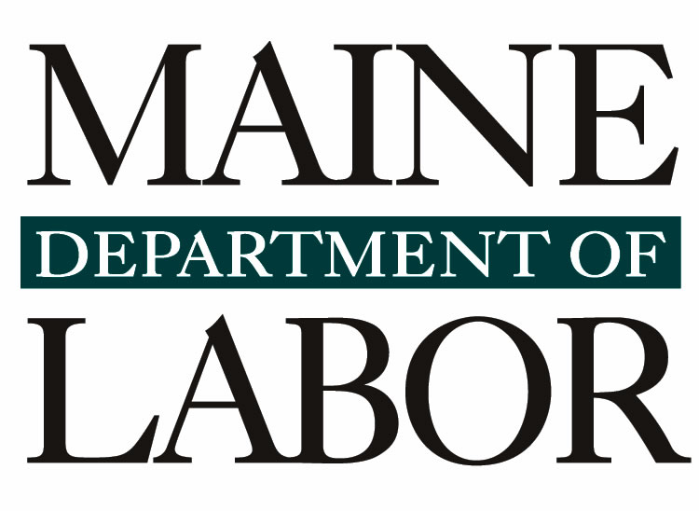
Maine Senior Community Services Employment Program (SCSEP) State Plan Modification 2026-2027

Introduction
Maine’s strategy for Program Years 2026–2027 focuses on strengthening the State SCSEP program as an integral part of Maine’s broader workforce development system and expanding opportunities for low-income older Mainers to achieve economic self-sufficiency through community service employment, skills development, work-based learning, and transitions to unsubsidized employment. Consistent with Executive Order 14278, Preparing Americans for High-Paying Skilled Trade Jobs of the Future, and the five strategic pillars of America’s Talent Strategy: Building the Workforce for the Golden Age, as referenced in TEGL 14-25, Maine will strengthen coordination among the State SCSEP and the National SCSEP grantee (Associates for Training and Development (A4TD)), CareerCenters, employers, host agencies, community-based organizations, education and training, and other workforce and supportive service partners, These efforts will focus on expanding employer and industry engagement, aligning participant training and community service assignments with local labor market needs, strengthening work-based learning and pathways to unsubsidized employment, improving coordination and accountability across the workforce system, and using technology appropriately to improve access to services and employment opportunities for older workers.
Since July 2025, the Maine Department of Labor, Bureau of Employment Services, has been responsible for managing and administering the State of Maine’s Senior Community Service Employment Program (SCSEP). With the transfer of the administration of the State SCSEP grant from the Maine Department of Health and Human Services in PY2025, the Maine Department of Labor's Bureau of Employment Services (BES) has administered the program for Cumberland and Lincoln Counties and part of York County.
Associates for Training & Development (A4TD), the National Grantee, continues to serve 14 counties: Androscoggin, Aroostook, Franklin, Hancock, Kennebec, Knox, Oxford, Penobscot, Piscataquis, Sagadahoc, Somerset, Waldo, Washington, and part of York.
The Maine SCSEP State Plan focuses on Title V of the Older Americans Act, which is the Senior Community Service Employment Program (SCSEP). This State Plan Modification is written in accordance with the United States Department of Labor (US DOL) Training and Employment Guidance Letter (TEGL 09-23 and TEGL 14-25) and 20 CFR § 641.300.
The purpose of the Maine SCSEP State Plan is to describe the statewide provision of authorized activities for eligible participants. The overarching goal of this SCSEP State Plan is:
GOAL: Improve the financial well-being of unemployed, low-income older adults in Maine seeking unsubsidized employment.
In applicable sections, the State Plan Modification describes current operations with objectives and strategies that Maine will take to achieve this State Plan goal. The outlined objectives and strategies will be implemented during the program years 2026-2027, which cover a two-year period from July 1, 2026, to June 30, 2028.
The final draft of the Maine SCSEP State Plan modification was disseminated and posted for public comment and questions for five consecutive calendar days between July 20, 2026, and July 24, 2026. This State Plan will be reviewed at least annually over the next two years to guide the ongoing operations and strategies of SCSEP within Maine.

Alignment with Federal Workforce Development Priorities

Maine’s SCSEP strategy for Program Years 2026–2027 supports the broader workforce development priorities reflected in the five pillars of the federal workforce strategy. While maintaining SCSEP’s distinct statutory purpose and focus on eligible low-income older workers, Maine will strengthen the program’s connection to the broader workforce system as follows:

Pillar I – Industry-Driven Strategy: Maine will strengthen connections and use a sector-based service delivery model that engages SCSEP, employers, host agencies, CareerCenters, and industry partners to better align community service assignments, participant training, and employment pathways with local labor market needs and occupations offering opportunities for older workers.

Pillar II – Worker Mobility: SCSEP will support older workers in developing skills, overcoming barriers to employment, and progressing toward economic self-sufficiency and unsubsidized employment. Participants will be connected, as appropriate, to CareerCenter services, training, Registered Apprenticeship, supportive services, and other workforce resources that can support continued career advancement.

Pillar III – Integrated Systems: Maine will strengthen coordination among the State and National SCSEP grantees, CareerCenters, host agencies, employers, community-based organizations, and other workforce and supportive service partners. Improved referrals and coordination will help ensure that SCSEP participants can access the broader range of services available through Maine’s workforce development system.

Pillar IV – Accountability: MDOL will continue to strengthen program and fiscal oversight, subrecipient monitoring, performance management, and the use of data to assess participant outcomes and program effectiveness. Maine will use performance information to support continuous improvement, responsible stewardship of federal resources, and stronger outcomes for SCSEP participants.

Pillar V – AI, Flexibility, and Innovation: Maine will explore the responsible use of technology and innovative service-delivery approaches to improve outreach, access, career navigation, digital literacy, and employment services for older workers. Recognizing that some SCSEP participants may face digital barriers, technology will be used to complement—not replace—individualized, person-centered assistance.

Together, these strategies will help strengthen SCSEP’s integration within Maine’s broader workforce development system while preserving the program’s unique role in providing community service employment, skills development, supportive services, and pathways to unsubsidized employment for low-income older Mainers.

Overview of the Senior Community Service Employment Program
The Senior Community Service Employment Program (SCSEP) is a community service and work-based training program, providing training for Maine’s low-income, unemployed older workers age 55+. The United States Department of Labor, Employment and Training Administration (ETA) distributes SCSEP funds to national and state grantees, whereas the national SCSEP grantees operate across multiple state jurisdictions and receive the majority of SCSEP funds. Since assuming responsibility for the State SCSEP grant from the Maine Department of Health and Human Services in PY2025, the Maine Department of Labor's Bureau of Employment Services (BES) has administered the program for Cumberland, York, and Lincoln Counties. MDOL is a trusted door through which older jobseekers seek assistance. More than 30.4 percent of jobseekers who utilized CareerCenter services in Cumberland, York, and Lincoln Counties during Performance Year 2025 were age 55 and older; 899 of whom received Wagner-Peyser-funded Career Services and Training from MDOL CareerCenter staff. (Wagner-Peyser Annual Report through Tableau WIOA Annual Report).

The Department carries out this mission through seven organizational units:
- The Bureau of Employment Services
- The Bureau of Labor Standards
- The Bureau of Rehabilitation Services
- The Bureau of Unemployment Compensation
- The Center for Workforce Research and Information
- The Paid Family and Medical Leave Program
- The State Workforce Board
MDOL will house the State Senior Community Service Employment Program Grant under the umbrella of the Bureau of Employment Services (BES). This is appropriate positioning for the State SCSEP Grant as BES provides a variety of employment and training services for Maine workers, businesses, and jobseekers through the Maine CareerCenter Network. BES is the hub in the network of local workforce development boards, WIOA service providers, and workforce community partners. Within BES, the State SCSEP MDOL will be utilizing a subrecipient to provide direct participant services and program activities.
MDOL is contracting with Associates for Training & Development (A4TD) to provide direct participant services under the State SCSEP grant. A4TD currently serves as the sole subrecipient responsible for direct participant services, host agency development, case management, participant recruitment, employment services, and day-to-day program operations within the State SCSEP service area.
A4TD serves as the only National SCSEP grantee in Maine, is a SCSEP National grantee and State sub-grantee in neighboring states, and brings extensive experience in participant recruitment, host agency development, case management, supportive services, and employment placement. The existing partnership between MDOL and A4TD supports coordination of services, referral pathways, and consistent program delivery throughout the state.
The State of Maine receives Older Americans Act funding from ETA through an annual grant process.
Participants in SCSEP must be residents of Maine, 55 years of age or older, unemployed, and have a family income at 125% or less of the poverty level (after allowable exclusions), as established by the United States Department of Health and Human Services (US DHHS). Service priority is given to individuals who meet one or more of the following barriers to employment:
- Are covered persons in accordance with the Veterans Opportunity to Work (VOW) (covered persons who are SCSEP eligible must receive services instead of or before all non-covered persons);
- Are 65 years or older;
- Are of a racial or ethnic minority group;
- Have a disability;
- Have limited English proficiency;
- Have low literacy skills;
- Reside in a rural area;
- Have low employment prospects;
- Have failed to find employment after utilizing services provided under Title I of the Workforce Innovation and Opportunity Act (WIOA);
- Are homeless or are at risk for homelessness; or
- Have been incarcerated within the last 5 years or is under supervision following release from prison or jail within the last 5 years.
Unsubsidized employment is the primary outcome of the Program. SCSEP provides subsidized paid training opportunities at 501(c)(3) non-profit businesses and government municipalities/agencies as Host Sites. Paid training opportunities allow participants to learn new job skills and gain valuable knowledge that is marketable.

SCSEP works in tandem with the Maine “Employment First” Statute, which was enacted on June 22, 2013. Maine Department of Labor aligns with the requirements of the Employment First Maine Act that offer employment as a core component of services and supports; provide employment as the first and preferred service or support option; and coordinate efforts and information with other State of Maine agencies. Maine WIOA State Plan is also aligned with this Employment First State statute, requiring that competitive integrated employment be the first and preferred service or support option offered by state agencies to individuals with disabilities. The State of Maine is committed to education, training, and job placement for its citizens with significant barriers to employment.

Demographics of Population Served
According to the most recent U.S. Census Bureau population estimates, Maine continues to have the oldest population of any state in the nation, with a median age of approximately 44.8 years. Maine is geographically the largest state in New England and among the most rural states in the nation. (World Population Review: “Most Rural States in the United States 2025,” Retrieval date July 28, 2025; https://worldpopulationreview.com/state-rankings/most-rural-states) Maine had a total population of 1,414,874, according to the Maine State Economist's January 30, 2026, estimates. While Maine's total senior population (age 65 and over) is only a little over 322,000, the state has the highest concentration of senior residents (23.00%) among all U.S. states.

The median age of Maine seniors is 72.9 years. (US Census Bureau, 2020 Census and 2023 Population Estimates, Retrieval date July 28, 2025; https://data.census.gov/profile/Maine?g=040XX00US23; and Rector, Amanda, Maine State Economist, Maine Department of Administrative and Financial Services; “Demographic and Economic Overview of Maine,” February 12, 2025; 2025 Muskie School of Public Service Rector slides) “In recent years, the proportion of young people in Maine has declined more rapidly than in other New England states. Additionally, most counties in Maine have experienced relatively slow rates of population growth. This has led to a constrained workforce in the state… Maine’s Department of Health and Human Services estimates 28% of Mainers will be 65 years old or older by 2030.” (Toscano, Maria, “Population over 65 by state,” Consumer Affairs Journal of Consumer Research, Updated March 24, 2025; https://www.consumeraffairs.com/homeowners/elderly-population-by-state.html#senior-population-by-state)

Per a study of longer trends published by Maine’s Center for Workforce Research and Information, “Demographic and Workforce Changes in Maine,” the sharp increase in jobs held by workers age 65 and older (183%) significantly outpaced the growth of the senior population (70%). The distribution of jobs across age groups has also shifted - Jobs held by people 55 and over increased from 16 to 28 percent, and the share held by those 35-54 decreased from 50 to 40 percent.” (Center for Workforce Research and Information, “Demographic and Workforce Changes in Maine” March 2025)

Based on the Maine Department of Labor’s Demographic Outlook Report: 2024 to 2034, the employment structure is projected to become older. The state population is projected to continue to grow through 2034. The rate of population change is projected to slow to about 2 percent from 2024 through 2034. Mostly due to falling birth rates over many years, the population between ages 16-64 is expected to decline by about 5 percent from 2024 through 2034.
The employment trend has closely followed the trend in the size of the age 16-64 population (the demographic group that holds the overwhelming majority of jobs). A rising trend in job holding among the age 65 and over group (mostly due to the large segment of the population aging into this group) is expected to offset somewhat the impact of the decreasing size of the age 16-64 population on total employment. The report is also using Maine State Economist projections.
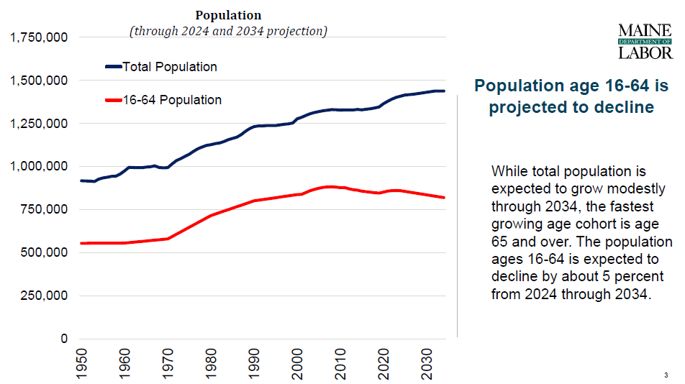

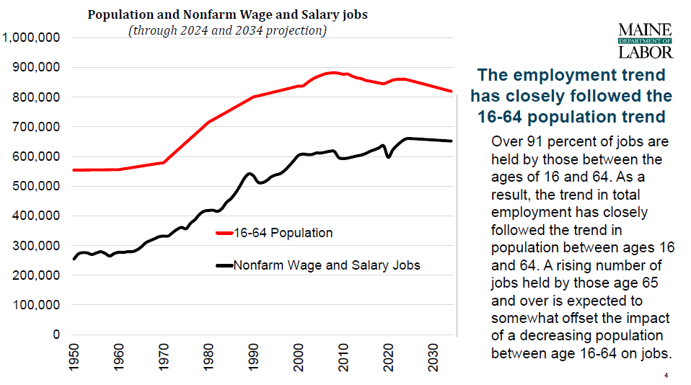
Maine also has one of the nation’s highest proportions of older adults, reflecting a long-term demographic trend driven by lower birth rates, increased longevity, and the aging of the state’s population. These demographic changes have significant implications for Maine’s workforce, as the state faces a constrained supply of working-age individuals while a growing number of older Mainers remain interested in or need to continue participating in the labor force. This demographic context underscores the continued importance of the Senior Community Service Employment Program (SCSEP) in Maine. SCSEP provides eligible low-income older adults, including individuals facing multiple barriers to employment, with opportunities to gain skills and recent work experience through community service assignments, access supportive services, and prepare for transition to unsubsidized employment. As Maine continues to address workforce shortages and an aging population, strengthening connections between SCSEP, the broader workforce development system, host agencies, employers, and community partners will be critical to supporting the economic self-sufficiency of older Mainers while recognizing their skills, experience, and continued contributions to Maine’s workforce and communities. While program-eligible older workers must be 55 years of age or older, unemployed, and with family income at 125% or less of the federal poverty level, reliable data sets that include all three characteristics are not readily available for the state or counties of Maine. Below are the best available data on characteristics outlined in 20 CFR § 641.325.

Age
Although the southern counties of Maine have higher overall populations, and therefore higher total populations of individuals 55 years and over below 100% of the federal poverty level (see Figure 1), the northern counties have higher percentages of individuals 55 years and over below 100% of the federal poverty level (see Figure 2).¹ This difference speaks to the availability of more jobs with higher wages in the southern counties and lower-paying jobs that are typically agriculturally related in the northern counties.
Figure 1 Figure 2
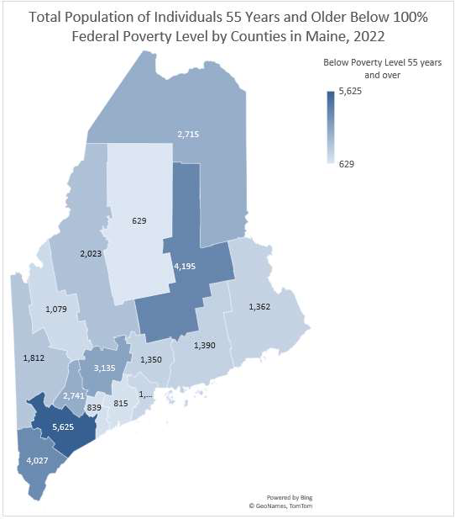
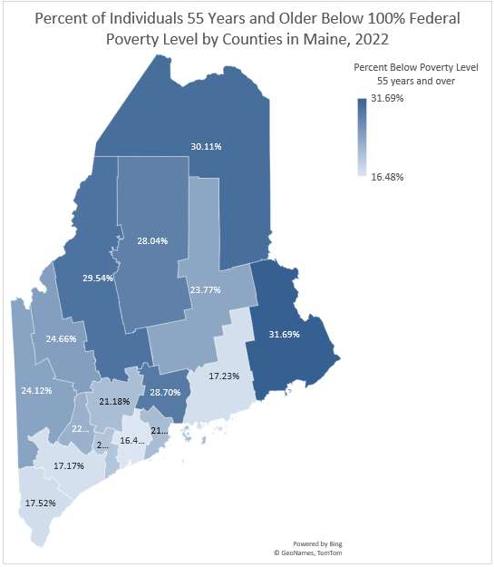

¹ U.S. Census Bureau, 2022 American Community Survey. Table S1701: Poverty Status in the Past 12 Months. Accessed January 2024.

Unemployment by Age

A 2018 study suggests that age alone is a contributing factor to the duration of unemployment for older workers and decreases the rate at which they find a job.² In Maine, the rate of unemployment starts very high for younger people and declines for those in their middle ages, but the unemployment rate increases again for older workers (see Figure 3)³. Due to recent and current economic environments, workers are participating in the labor market well past typical retirement ages.
Figure 3
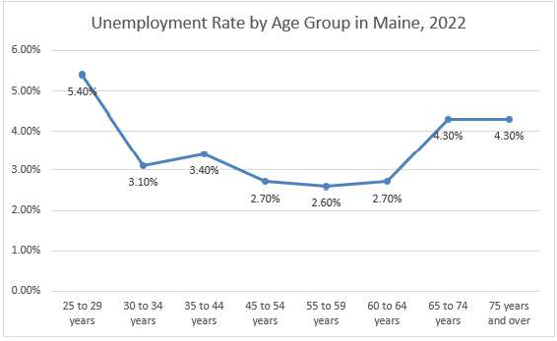

While participants must be 55 years of age or older, one objective of Maine’s SCSEP is to target outreach to adults ages 65 and above who are unemployed and seeking a job. Using data and findings from the 2023 Maine State Plan on Aging Needs Assessment, nearly three-quarters of respondents used the Internet to find information on available services, but this varied by age (Figure 4). Other common sources of information among survey respondents were doctors or health care providers, word of mouth, television, and newspapers.

_________________________________
² Axelrad, H., Malul, M., & Luski, I. (2018). Unemployment among younger and older individuals: does conventional data about unemployment tell us the whole story? Journal for Labor Market Research, 52(1). doi: 10.1186/s12651-018-0237-9
³ U.S. Census Bureau, 2022 American Community Survey. Table S2301: Employment Status.

Figure 4
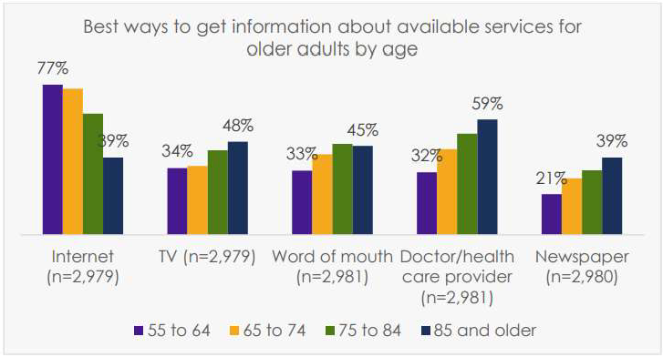

Although the internet was identified as one of the best ways to get information about services, this varied by income. Using the internet was strongly associated with higher income. A little over half (52%) of older adults with incomes below $20,000 use the internet to find information about available services compared to 83% of those with incomes over $75,000. (Figure 5).
Figure 5
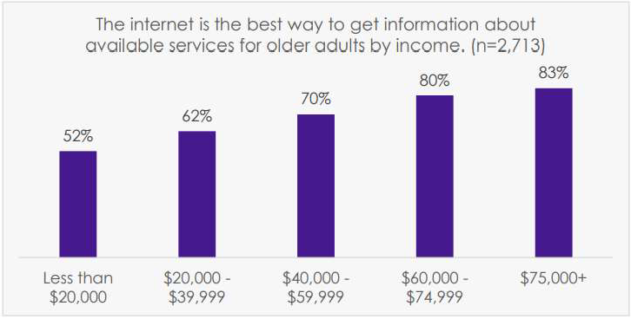

These data and findings inform how both MDOL and A4TD conduct outreach to low-income, older adults in Maine, especially those over the age of 65. The following objectives and strategies are also informed by these findings:
OBJECTIVE 1: Target outreach to adults ages 65 and above who are unemployed and seeking a job.

STRATEGIES:
- Using Labor Market Information and employer feedback, develop a worker-centered, sector-based strategy to target older adults who are interested in working in high-growth, in-demand industries.
- Use social media platforms often used by older adults and other digital marketing tools to access potential SCSEP applicants online.
- Use traditional outreach methods like flyers, newsletters, and newspapers.
- Partner with Maine CareerCenters across the state to identify potentially eligible individuals and provide educational materials about the benefits of the SCSEP.
- SCSEP grantees will utilize their partner relationships and partner networks to access SCSEP applicants, requesting client referrals for those who are eligible and interested in returning to the workforce.
- To the maximum extent practicable, explore other outreach methods like television and non-traditional partners like health care providers.

Greatest Social Need

Demographic Characteristics and Access to SCSEP Services:

Maine’s SCSEP programs (National and State) provide access to all individuals who meet the federal eligibility requirements for the program, without discrimination on the basis of race, color, religion, sex, national origin, disability, age beyond the statutory SCSEP eligibility requirements, or any other characteristic protected by applicable federal law. Participant eligibility, enrollment, community service assignments, training, supportive services, and employment assistance are based on applicable SCSEP statutory and regulatory requirements and the individual participant’s employment needs, skills, barriers, and Individual Employment Plan.

Consistent with SCSEP requirements, Maine will continue efforts to reach eligible older adults with the greatest economic and social need, as those terms are defined and applied under the Older Americans Act and applicable SCSEP requirements. Outreach and recruitment will be conducted using lawful, objective, and nondiscriminatory approaches designed to ensure that information about SCSEP is broadly accessible to potentially eligible individuals throughout the state.

The State Grantee and National Grantee will continue to collaborate with CareerCenters, Area Agencies on Aging, community-based organizations, social service providers, host agencies, and other partners that serve older adults and individuals experiencing barriers to employment. These partnerships may assist with program awareness, referrals, recruitment, community service opportunities, supportive services, and connections to employment. Participation in SCSEP and access to program services will remain open to all eligible individuals and will not be conditioned on race, ethnicity, national origin, sex, religion, or any other protected characteristic.

Maine recognizes that eligible older adults may face a range of barriers to employment, including low income, homelessness or housing instability, limited English proficiency, disability, rural isolation, transportation challenges, limited digital access or skills, long-term unemployment, and other circumstances recognized under applicable SCSEP law and policy. Maine will continue to provide individualized, person-centered services and appropriate referrals based on each participant’s circumstances and employment goals.

All SCSEP activities and the use of federal funds will be administered in accordance with the United States Constitution and applicable federal civil rights laws, including Title VI and Title VII of the Civil

Rights Act of 1964, Title IX of the Education Amendments of 1972, Section 504 of the Rehabilitation Act, the Age Discrimination Act of 1975, Title II of the Americans with Disabilities Act of 1990, and other applicable federal requirements. Maine will also ensure that subrecipients and other entities administering SCSEP-funded activities comply with applicable nondiscrimination requirements.

Veterans
Maine SCSEP grantees are well connected to the JVSG program, which is situated under the umbrella of the Bureau of Employment Services, MDOL, and also outreaches to the U.S. Department of Veterans Affairs Maine Health Care System to recruit veterans potentially eligible to participate in SCSEP. Specifically, Maine SCSEP grantees have partnered with the Healthcare for Homeless Veterans Program to identify strategies to increase enrollment through sharing SCSEP program materials and information.

Disability
The percentage of older adults in Maine with disabilities tends to increase with age. Women experience higher rates of disability in later life compared to men, especially in independent living and mobility¹¹ (Figure 7).

Figure 7- Women experience increasing rates of disabilities with age compared to men.
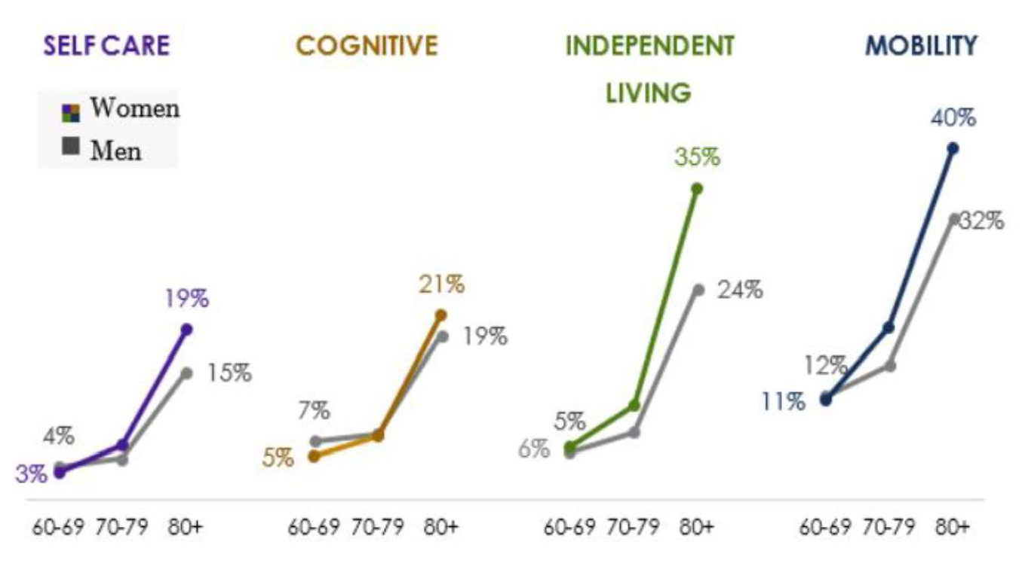

Supportive services can include transportation, health, and medical services, special job-related or personal counseling, incidentals (such as work shoes, badges, uniforms, eyeglasses, and tools), child and adult care, housing, including temporary shelter, follow-up services, and needs-related payments, which are necessary to enable an individual to participate in activities authorized under the SCSEP. A4TD screens for the need for supportive services during the initial intake process and periodic recertifications. When placing participants at host agencies, SCSEP staff work with both the participant and the host agency to identify training opportunities that accommodate any disability.

Limited English Proficiency
Along Maine’s northern border, many dual citizens have family and friends who live in Canada. French is often spoken in homes and in the community where English is not taught to children until grade school.
Additionally, there is a growing population of New Mainers of all ages who are choosing Maine as their home and speak a language other than English. In Maine, 16.6% of those who speak a language other than English at home have family household incomes that are below 100% of the federal poverty level compared to 10.4% of those who speak only English at home.⁴ Efforts have been made by grantees in Maine to translate program materials into languages other than English. A4TD offers translation service when appropriate.

Rural
While Rural Urban Commuting Area (RUCA) codes are used to determine rural status for SCSEP participants, it is important to highlight the rurality of Maine. When applying the 2020 US Census Urban Areas Criteria definition of urban (2020 Census Urban Areas FAQs) to Maine, 489 of Maine’s 533 municipalities meet the criteria for rural, with only 18 municipalities meeting the urban criteria. Both grantees in Maine experience transportation in rural areas as the largest barrier to participation for applicants, especially to and from host agencies. As such, grant funds are used to address this barrier through supportive services, like bus passes (if available). Maine rural communities are challenged to access to technology and internet connectivity. To address the need, A4TD uses Optional Additional Training and Supportive Services (OATSS) funds to provide technology and internet services. A4TD’s Technology Program and the corresponding Peer-to-Peer Mentoring Program are two significant special projects that were started to enhance SCSEP service delivery during the pandemic. Participants are given technology (Chromebook) and/or an internet connection (MIFI) to complete virtual training and job search. In parallel, participants (mentees) are mentored by fellow participants (mentors) in how to use the technology. These projects are having a very positive impact on participants and facilitate enhanced training that moves them toward job readiness and employment.
Additionally, Maine SCSEP grantees will work with local economic development districts that cover rural locations in Maine to ensure that the needs of low-income, unemployed older individuals are represented in economic development strategic plans. Maine SCSEP grantees will partner with the local economic development districts to identify potential opportunities based on current strategic plans. This will include reviewing and commenting on proposed plans to provide recommendations to strengthen objectives and strategies.

Unhoused and Housing Insecure
The eligibility requirements for SCSEP are highly correlated with housing insecurity. The shortage of affordable housing, which has become increasingly pronounced in recent years, continues to present significant challenges for Maine's workforce and affects the ability of many older adults to obtain and retain employment. Housing stability is closely linked to economic security, and individuals experiencing housing insecurity often face additional barriers to securing unsubsidized employment.

Consistent with the U.S. Department of Labor's America's Talent Strategy, particularly its emphasis on worker mobility and integrated workforce systems, Maine's SCSEP program works collaboratively with workforce, housing, and community partners to reduce barriers to employment and promote long-term economic self-sufficiency. Recruitment and outreach efforts include coordination with low-income housing providers, local housing authorities, homeless service organizations, and other community-based partners to identify and engage eligible older adults who may benefit from SCSEP services. Through these partnerships, SCSEP seeks to connect participants with employment opportunities while also facilitating access to supportive services that contribute to housing stability and successful workforce participation.
_______________________________
⁴ U.S. Census Bureau, 2022 American Community Survey. Table S1603: Characteristics of People by Language Spoken at Home. Accessed January 2024.

Recently Incarcerated
SCSEP grantees in Maine recruit members based on priority of service, which includes formerly incarcerated individuals. Local areas boards and their providers, and MDOL CareerCenters are aware of the projects that include the provision of career services in pre-release and county jails that educate soon-to-be-released inmates about job search and workforce training resources and that establish relationships between them and prospective employers. Maine is also working with employers to reduce concerns about hiring justice-involved individuals. Previous job fair-like events have been held at two Maine State Prison facilities. Employers who attended reported that it helped them to better understand the system as well as the rehabilitation and education programs in which inmates participate. In addition, Maine is promoting the Work Opportunity Tax Credit (WOTC) and the Federal Bonding Program as incentives to employers considering hiring justice-involved individuals. The MDOL and DOC recently agreed to a partnership where DOC staff will pre-certify for WOTC and issue Federal Bond vouchers to inmates as part of their release processing. These justice-involved individuals will leave correctional facilities with documents offering incentives to employers who hire them.

MDOL has established collaboration with the Maine Prisoners Re-entry Network (MPRN), a resource hub for individuals who are returning to the community after incarceration. The MPRN holds weekly meetings to support citizens who have been recently incarcerated. Currently, these meetings are held virtually, allowing for statewide access to support connections with community organizations. Attendance at these weekly meetings has allowed the SCSEP grantees to form a working relationship with the founder of MPRN and share SCSEP eligibility requirements with attendees statewide, including individuals currently incarcerated.

The Maine Department of Labor recognizes the importance of strengthening partnerships that expand employment opportunities for individuals with significant barriers to employment, including formerly incarcerated individuals. Through collaboration with Local Workforce Development Boards and regional partners, SCSEP will seek opportunities to connect participants with innovative workforce initiatives such as Recovery Friendly Workplace (RFW) Networks. These locally led partnerships help employers build supportive, resilient workplace cultures by reducing stigma, promoting well-being, and connecting businesses with workforce and community resources. Such collaborations create more inclusive employment environments and support successful workforce participation for individuals reentering the labor market following involvement with the justice system.
The following objectives and strategies will help ensure that SCSEP services in Maine are prioritized for those with the greatest social need during this state plan:
OBJECTIVE 2: Target recruitment efforts to eligible older individuals with the greatest social need.

STRATEGIES:
- Strengthen partnerships with community organizations serving individuals with disabilities, homeless persons, veterans, and other groups.
- Educate future employers and SCSEP staff about workplace accommodations for older adults with disabilities for successful outcomes upon exiting SCSEP.
- Partner with the Division of Vocational Rehabilitation within the Maine Department of Labor to educate staff about SCSEP, recruit participants, provide skill training, and identify host organizations that best fit the participant’s needs.
- Continue to identify the most common languages used by applicants and participants to provide translated program materials.
- Provide supportive services that address the needs of participants, especially those who live in rural areas.
- Coordinate recruitment efforts with low-income housing providers and local housing authorities.
- Continue to participate in Maine Prisoners Re-entry Network (MPRN) meetings to educate recently incarcerated older adults about the benefits and services of SCSEP.

Economic Projections and Impact
The State of Maine has been transformed since the days of the pulp and paper industry, the shoe industry, boatbuilding, fishing, and the potato industry. Given Maine’s ambitious and dedicated workforce and our state’s endowment of forests, coastline, and farmland, there are industry clusters the Maine Office of Business Development has identified as having the highest growth potential. These include Forest Products, Life Sciences, Marine/Aquaculture, Food/Agriculture, and Outdoor Recreation. However, the skills and training of older workers, especially those who are low-income and unemployed, may not meet the needs of these industries.
Industry sectors in Maine that employ most nonfarm wage and salary workers over age 55 are Healthcare and Social Assistance, Retail Trade, Educational Services, Manufacturing, and Construction (see Figure 6)5

Figure 6
Full-Quarter Employment (Stable): Counts, 2021-2022, Ages 55 to 99
30000

25000

20000

15000

10000

5000

0
Health Care and Social Assistance
Retail Trade
Educational Services
Manufacturing
Construction

Q1 | Q2 | Q3 | Q4 | Q1 | Q2 | Q3 | Q4
2021 | 2021 | 2021 | 2021 | 2022 | 2022 | 2022 | 2022

_______________________________________
⁵ U.S. Census Bureau, Longitudinal Employer-Household Dynamics, Quarterly Workforce Indicators (QWI), 2021Q1-2022Q4 https://ledextract.ces.census.gov/static/data.html

The most common industries older people tend to hold stable jobs demonstrated above are not always the highest paying industries for older workers, except in Health Care and Social Assistance for older female workers. In 2023 Q1, the highest average monthly earnings of stable employees ages 55+ vary by age and gender, as shown below in Figure 7 and Figure 8.

Figure 7
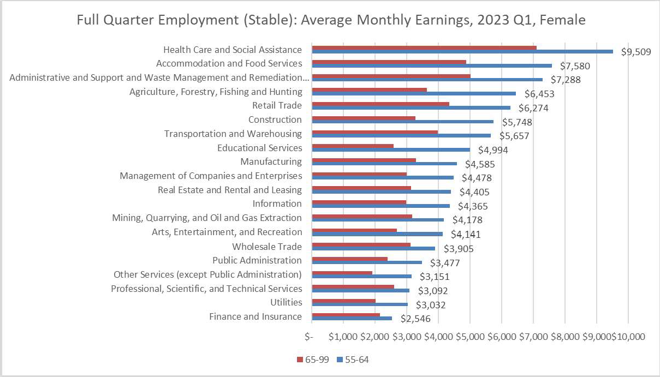

Figure 8
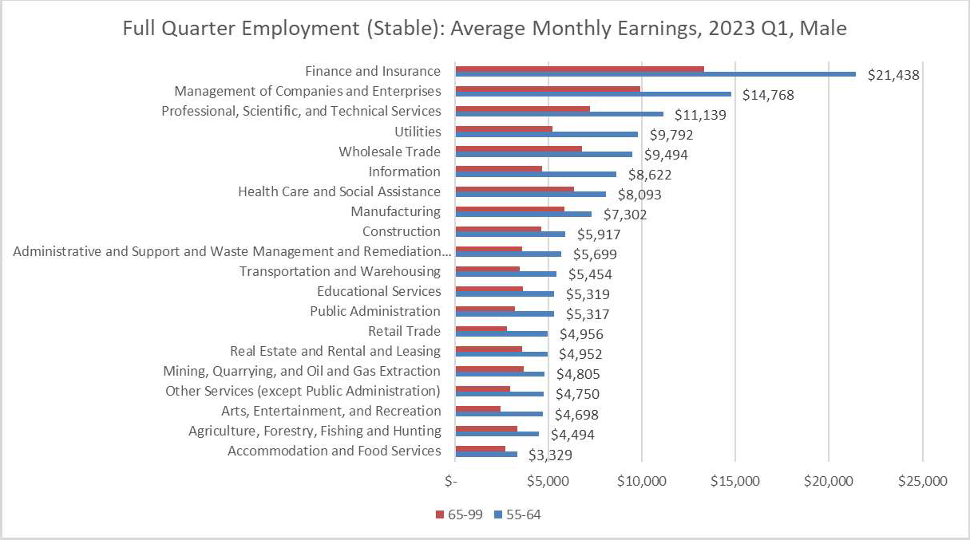

The Health Care and Social Assistance sector is the most common occupation for older workers in general and has the highest monthly earnings for older female workers ($9,509), and the 7th highest monthly earnings for older male workers ($8,622). The Retail Trade sector is the second most common occupation for older workers in general and has the 5th highest monthly earnings for older female workers ($6,274), and the 14th highest monthly earnings for older male workers ($4,956). It is important to note that these figures are average monthly earnings and do not necessarily represent entry-level earnings for older workers, which is the most common type of unsubsidized employment participants in SCSEP enter upon exit from the program.
In Maine, some groups of occupations will experience much larger rates of job change than others. That said, the overall occupational composition of employment is expected to change modestly, continuing the gradual evolution that has been underway for decades. As an example, jobs in the office and administrative support and the sales groups are expected to experience the largest net decreases through 2030. They are also expected to remain the two largest occupational groups by employment and provide the second and third largest numbers of job openings.⁶

______________________________________
⁶ Maine Department of Labor, Center for Workforce Research, and Information Employment Outlook to 2030, https://www.maine.gov/labor/cwri/publications/pdf/OccupationalOutlook2030.pdf

Figure 9
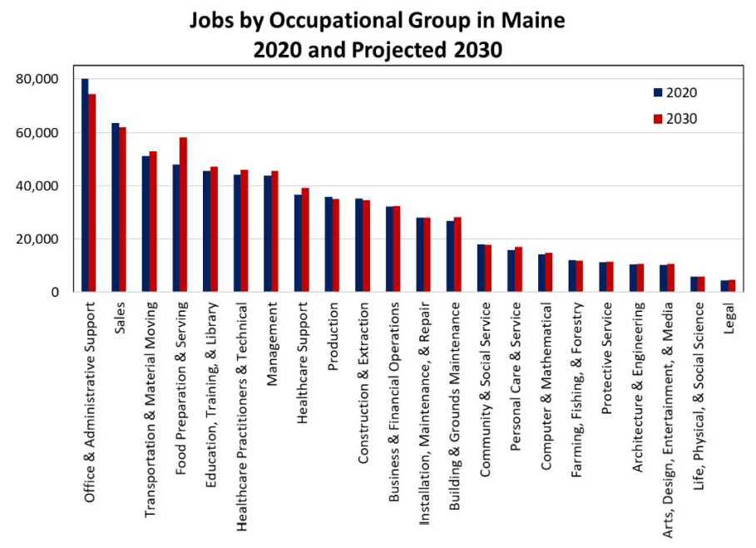

Education level is an important factor that determines the type of jobs held by older workers and their average monthly earnings. The top occupations with the largest projected number of annual openings between 2020 and 2030 in Maine that require a high school diploma or less are:⁷

__________________________________________
⁷ Maine Department of Labor, Center for Workforce Research, and Information. (2024Employment and Job Openings in Maine in 2020 and Projected 2030, https://www.maine.gov/labor/cwri/outlook.html
Figure 10
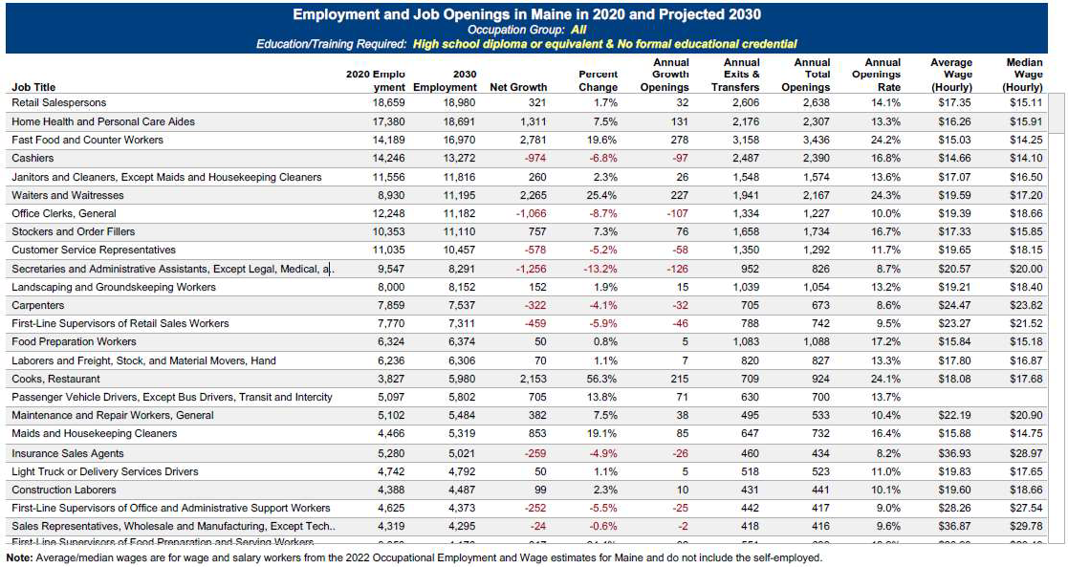

The State of Maine establishes different training requirements for personal care and home health aides depending on their place of work (i.e., in a facility vs. the home) and the population served. As such, a person-centered approach is required to identify the training needs of participants interested in entering this occupation. For the other occupations, there are common job skills that easily translate to other occupations not listed. One common skill that is needed across the occupations with the highest projected openings and often held by older workers is technology literacy.

Both the National and State Grantees build Individual Employment Plans (IEPs) to suit the assessed needs of the participants to help them succeed in their long-term employment goals. Additionally, information from O*Net and My Next Move has been successfully integrated directly into the SCSEP participants’ IEP by A4TD. Before a training assignment begins for the participant, A4TD staff and the Host Agency Supervisor will provide a skills self-assessment for each item in the Abilities, Work Styles, Work Activities, and Tasks sections for a specific occupation in the IEP. This assessment provides a blueprint for the participant by determining what skills and training(s) need to be developed, what skills the Host Site can address, and what skills need to be developed outside of the community service assignment. Within the first 6 months of the participants' enrollment, and in 6-month increments after, an assessment with the participant, A4TD staff, and the Host Agency Supervisor is performed to determine what skills the participant has become proficient in and which skills need improvement. This process highlights the participant’s training progress and identifies areas where additional training is needed to increase the participant’s ability to achieve unsubsidized employment. Host Sites will be selected based on their ability to provide an on-the-job experience that targets these common job skills. Figure 12 informs Maine SCSEP grantees of the sectors we should be training our older workers. Additional training resources will be identified based on the participant’s Individual Employment Plan.

Maine SCSEP develops job leads and identifies potential employers in the public and private sectors by advertising, attending job fairs, responding to ads in local newspapers, contacting employers (in person, by telephone, and by e-mail), offering the On-the-Job Experience (OJE) training option, and speaking at local business meetings. Maine SCSEP grantees focus on sector strategies to connect SCSEP participants with open opportunities in high-growth, in-demand sectors. For example, Healthcare is the largest growth sector in Maine. Maine’s SCSEP grantees will prepare older workers who can perform duties in a healthcare setting for those jobs, whether it be a companion, Personal Care Attendant, Certified Nursing Assistant, phlebotomist, etc. Efforts will include talking with healthcare providers to see what skills they need in an employer, connecting with training providers to provide credentialed training, and then recruiting SCSEP-eligible participants who want those jobs.

All SCSEP participants will be required to register with Maine’s JobLink at the Maine CareerCenters (https://joblink.maine.gov/). Also, the Program will continue to use the Internet to access various job search sites to identify job opportunities for SCSEP participants. The SCSEP partnership with the Maine CareerCenters will be strengthened and improved to serve participants better. For example, CareerCenters will act as Host Sites for program participants across the state, and access to the Maine Job Bank for each participant will occur. SCSEP program managers and staff will routinely consult and coordinate with the Career Centers statewide.
Following each participant's transition to unsubsidized employment, SCSEP staff will conduct required follow-up activities with both the participant and the employer to support successful employment retention and assess employer satisfaction. Maintaining ongoing communication with employers strengthens long-term partnerships, improves participant retention, and increases the likelihood that employers will consider future SCSEP participants when employment opportunities become available.
To promote successful employment outcomes, the program emphasizes referring participants whose skills, experience, interests, and employment goals align with employer needs. Many SCSEP participants seek part-time employment with daytime schedules, reflecting the preferences of many older workers for flexible work arrangements that support work-life balance. Program staff work closely with employers to better understand the value of older workers, identify effective recruitment strategies, and foster workplace practices that support employee retention and long-term success.
Consistent with the U.S. Department of Labor's America's Talent Strategy, particularly its emphasis on demand-driven workforce development, worker mobility, and strong employer partnerships, the Maine SCSEP program prioritizes collaboration with community-based organizations, nonprofit agencies, public employers, and small businesses that offer meaningful employment opportunities aligned with participants' skills and career goals. These partnerships help create realistic pathways to unsubsidized employment while meeting local workforce needs.
Because many SCSEP participants face transportation challenges or reside in rural communities, they generally seek employment within their local labor markets and are less likely to relocate or accept lengthy commutes. Accordingly, Maine's SCSEP program focuses employer engagement efforts within local communities to maximize employment opportunities that are accessible and sustainable for participants.
SCSEP program staff will continue to regularly visit host agencies and training sites to strengthen relationships, monitor participant progress, and encourage host agencies to consider hiring qualified SCSEP participants when vacancies and funding permit. Staff will continue to highlight the value of hiring individuals who have successfully completed SCSEP training and have demonstrated the skills, reliability, and experience needed to contribute to the workforce.

On-the-Job Experience (OJE) Training
The Maine Department of Labor (MDOL), through its SCSEP subrecipient, Associates for Training and Development (A4TD), and A4TD, as the Maine National Grantee, will utilize the On-the-Job Experience (OJE) training option as an employment-focused strategy for eligible SCSEP participants when job-specific skills necessary to secure unsubsidized employment cannot be effectively obtained through a traditional Community Service Assignment (CSA), classroom training, or other available training opportunities.
OJE provides participants with structured, employer-based training designed to develop the specific skills and competencies required for a permanent position. OJE opportunities will be individualized and aligned with each participant’s Individual Employment Plan (IEP), employment goals, skills, and training needs. MDOL and A4TD will use labor market information and employer demand to identify appropriate opportunities in industries and occupations offering realistic pathways to unsubsidized employment.
Participating employers will be carefully screened to ensure that each OJE provides meaningful, job-specific training and a clear pathway to permanent employment. Prior to the start of an OJE, A4TD, the participant, and the employer will execute a written agreement identifying the position, training activities, skills to be developed, training period, performance expectations, and the employer’s commitment to hire the participant upon successful completion of the training.
OJE placements may provide up to 160 hours of employer-based training, completed within a period not to exceed 12 weeks, based on the participant’s individualized training needs. Participants will remain on A4TD’s payroll during the OJE and will receive 100 percent of the prevailing wage for the position. A4TD will provide ongoing monitoring and case management throughout the training period to assess participant progress, address health and safety considerations, and support a successful transition to unsubsidized employment. When an employer is prepared to hire the participant before completion of the approved training period, the OJE may conclude early, and the participant may transition directly into permanent employment.

Through OJE, Maine seeks to provide eligible participants—particularly those who require additional job-specific training to successfully compete for employment—with a structured bridge from SCSEP participation to unsubsidized employment. The OJE strategy will be administered in accordance with applicable SCSEP requirements, including the U.S. Department of Labor, Older Worker Bulletin (OWB) 04-04, Permissible Training Activities Under SCSEP, and all applicable federal program, fiscal, health and safety, and nondiscrimination requirements.

Service Delivery and Coordination
The Maine State and National SCSEP will strategically bring together workforce development boards, educational systems, and resource services in a seamless, customer-focused service delivery network. As a member of the three Local Workforce Boards and Maine’s One-Stop Delivery System, the goal is to collaborate and encourage co-enrollment across all WIOA training programs. Achievement of this vision will allow Maine to continue building a workforce development system that prepares older Mainers for high-demand jobs. These high-growth employment in industry sectors are vital for the continued economic growth of Maine.
The Maine State SCSEP program service delivery is contracted with the National SCSEP grantee, A4TD, to ensure seamless referrals and coordination of the SCSEP throughout Maine. The Maine SCSEP administrator will monitor program and fiscal compliance on at least a quarterly basis by entering and tracking relevant data points in the Grantee Performance Management System (GPMS), SCSEP’s data management system. Additionally, the SCSEP administrator will conduct periodic site visits to monitor host sites for compliance.
Maine SCSEP continues to work with and coordinate with several other agencies, including Catholic Charities of Maine, the Jewish Community Alliance, the American Red Cross, Community Action Agencies, and Area Agencies on Aging (AAA). These organizations, along with others, make referrals to and from SCSEP, and they are also used as Host Sites. For example, if a participant is having issues with their Medicare, they are referred to their local AAA. The local AAA will also be considered to be an SCSEP Host Agency. The State and National Grantees will make a concerted effort to increase their presence at these and other local non-profit agencies that serve Maine’s older adults.
For a list of community services provided that are needed, the places where these services are most needed, and the organizations provided services and programs to older individuals, please see the Maine State Plan on Aging Needs Assessment. One of the domains of need contained in the statewide needs assessment includes Employment and Volunteering (see page 159).
Fostering partnerships with employers is key to helping program participants secure unsubsidized employment once they exit the program. The primary objective of the SCSEP is to prepare older adults to return to the workforce. To facilitate this, the program works closely with local career centers to establish connections with businesses and organizations that are looking for employees. Establishing these connections is crucial to securing unsubsidized placements for participants who are ready to re-enter the workforce.
Maine SCSEP (both the National Grantee and State Grantee) is an active partner with Maine CareerCenters and the One-Stop delivery system. A4TD has an office at Portland CareerCenter for Cumberland County and the Tri- County CareerCenter in Penobscot County, and the space is provided by the Maine Department of Labor. Other CareerCenters in Maine house One-Stops and provide access for program participants to classes that occur regularly. Nine of the twelve CareerCenters are located between Bangor and Springvale, which cover most individuals aged 55 and above who are below the federal poverty level in Maine (see Figure 1). Below is a map and list of the CareerCenter locations across the state (see Figure 11). A4TD is a mandated partner of all three Workforce Development Boards in the state. Maine SCSEP grantees collaborate with CareerCenter by cross-referring participants, marketing the program through flyers, social media, and calendars, providing co-location services as an in-kind contribution, and coordinating WIOA training opportunities. A4TD hosts SCSEP participant job clubs (Network to Work SCSEP participant meetings) where CareerCenter staff present on job readiness topics. Additionally, they serve as a host site for both grantees.

Figure 11
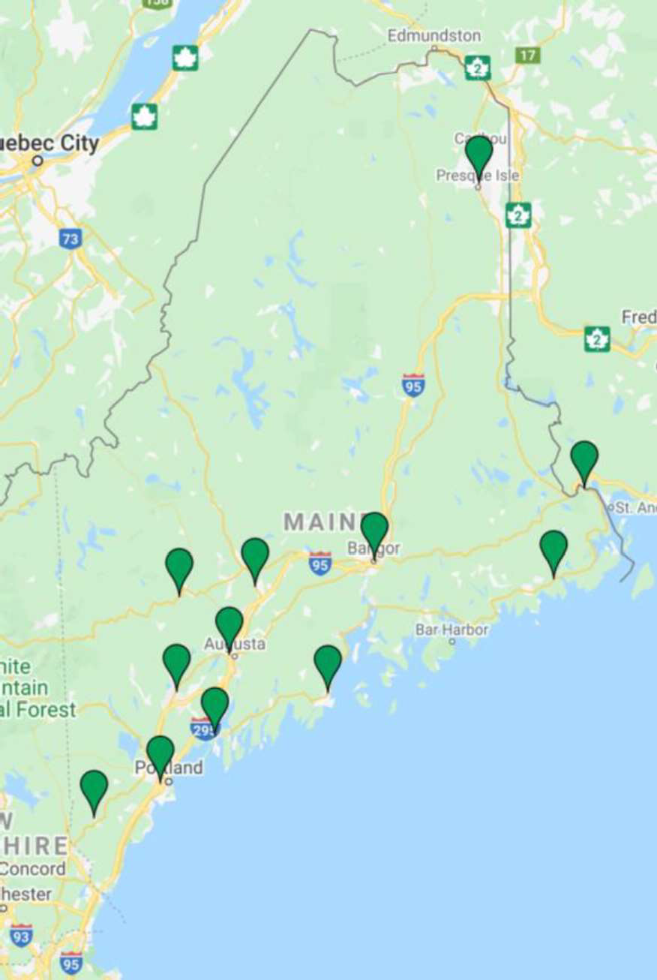

Location | Address | Phone Number
Augusta | 45 Commerce Drive, Augusta, ME 04330 | (207) 624-5120
Bangor | 45 Oak Street, Suite 3, Bangor, ME 04401 | (207) 561-4050
Brunswick | 29 Sewall Street, Brunswick, Maine 04011 | (207) 721-8200
Calais | One College Drive, Calais, ME 04619 | (207) 454-7551
Hinckley | 23 Stanley Road, Hinckley, ME 04944 | (207) 474-4950
Lewiston | 5 Mollison Way, Lewiston, ME 04240 | (207) 753-9001
Machias | 53 Prescott Drive, Suite 1, Machias, ME 04654 | (207) 255-1900
Greater Portland | 151 Jetport Blvd, Portland, ME 04102 | (207) 822-3300
Presque Isle | 66 Spruce Street, Suite 1, Presque Isle, ME 04769 | (207) 768-6829
Rockland | 91 Camden Street, Suite 201, Rockland, ME 04841 | (207) 596-2600
Springvale | 9 Bodwell Court, Springvale, ME 04083 | (207) 324-5460
Wilton | 865 US Route 2E, Wilton, ME 04294 | (207) 645-5800

The following objectives and strategies will help Maine SCSEP grantees deliver quality services while also educating participants and future employers about the Good Jobs Principles with a focus on the needs of older workers:
OBJECTIVE 3: Prepare participants in SCSEP for unsubsidized employment in high-growth, in-demand sectors that offer sustainable employment.

STRATEGIES:
- Ensure all SCSEP participants are registered with Maine’s JobLink at Maine CareerCenters.
- Continue to participate in local workforce development boards as part of Maine’s One-Stop Delivery System to encourage co-enrollment in other WIOA training programs.
- Develop high-quality Community Service Assignments that offer flexible types of training assignments (in-person, remote, or hybrid) to ensure that all participants are served equitably.
- Develop person-centered Individual Employment Plans (IEPs) that consider assessed needs for supportive services, training, and skills development.
- Provide appropriate referrals to other services, including OAA Title III, based on needs identified in IEPs.
- Educate participants about the Good Jobs Principles and in-demand job sectors during enrollment and the development of IEPs.
- Implement an Optional Additional Training and Supportive Services (OATSS) workplan that supports SCSEP participants in completing credentialed training that aligns with their IEP.

National and State Grantee Coordination
Maine is a small rural state that was hit hard by the overall decline of manufacturing industries. The central and northern counties were hit especially hard and continue to struggle with the loss of large amounts of paper mill jobs. Employment training and re-training have been essential in these areas to stabilize these areas of the state. Local non-profit social service agencies, such as Community Action Agencies, Commodity Supplemental Food Program (CSFP), Area Agencies on Aging, and faith-based agencies, are working across the state to provide all the needed services and the necessary safety net. All these agencies help to provide the services needed for low-income Mainers but are especially critical for older Mainers who have multiple barriers to employment and limited resources.
High-Priority Services Needed in Maine:
- Fuel Assistance (LiHEAP)
- Transportation
- Food (Meals on Wheels, SNAP, CSFP)
- Health Care
- Respite Care
- Long Term Care
- Job Re-training/Adult Education
- English as a Second Language

Under the direction and guidance of the State Grantee Program Administrator, the National Grantee and the State Grantee will meet at least monthly to discuss SCSEP and how best to implement the State Plan. The continued improvement of SCSEP in Maine is dependent on continued lines of communication between all parties involved.
For Maine SCSEP to continually improve upon the performance outcomes and goals of the program, there will be regular (at least monthly) coordination meetings between the National Grantee and State Grantee. The Plan and the goals of both the National and State Grantees will be standing agenda items. The employment-related outcomes will be a strict focus. The State SCSEP program manager will check the Quarterly Performance Report for both the State and National Grantees every time the report is released by the US DOL.

Performance Measures
The SCSEP program has established performance measures that the US DOL negotiates with both the National and State Grantees. The State and National Grantees are given different goals because the National Grantee works across multiple states. Every year, seven core measures are tracked, per 20 CFR § 641.710:
- Hours of Community Service Employment: Paid training hours are excluded from this measure. Formula (after adjusting for differences in minimum wage among the areas):
- Employment Rate Q2 After Exit: % of participants who are in unsubsidized employment during the second quarter after exiting the program. Formula:

- Employment Rate Q4 After Exit: % of participants who are in unsubsidized employment during the fourth quarter after exiting the program. Formula:

- Median Earnings: Of those participants who are in unsubsidized employment during the second quarter after exiting the program. Formula (for all participants who exited and are in unsubsidized employment during the second quarter after the exit quarter):
- Program Assessment: The combined results of customer assessments using indicators of effectiveness in serving employers, host agencies, and participants.

- Number of Participants Served: The number of eligible participants served. Formula (after adjusting for differences in minimum wage among the areas):
- Service to Most-in-Need: The number of participating individuals described in OAA Sec. 518(a)(3)(B)(ii) or (b)(2) and 20 CFR § 641.710 (g). Formula:

In order to meet these annual goals, Maine’s SCSEP program will continue to strengthen coordination with the Maine Department of Labor’s CareerCenters, the State Workforce Development Board (SWDB), and the three Local Workforce Development Boards to promote employment and training opportunities for eligible older workers. In addition, the Bureau of Employment Services (BES) leadership actively participates in the Maine Cabinet on Aging, providing an important opportunity to coordinate workforce initiatives with broader state efforts to support healthy aging, economic security, and community engagement for older Mainers. As Maine’s SCSEP subrecipient, Associates for Training and Development (A4TD) is also establishing a collaborative relationship with the Cabinet on Aging to explore opportunities for SCSEP to support and benefit from the Cabinet’s initiatives, particularly those that increase the visibility of older Mainers, promote their continued contributions to Maine’s workforce and communities, and expand pathways to employment and economic self-sufficiency.

Through these partnerships, Maine will continue to foster coordinated planning, information sharing, and cross-sector collaboration to better serve older workers across the state. Maine will continue to grow its relationship with the Local Workforce Boards and MDOL Career Centers. SCSEP is designed to help participants access local Adult Education classes and other training opportunities. The program is promoted regularly at Job Fairs across the state, and information is also shared with various entities like the Maine State Chamber of Commerce and local Chambers. To ensure access to the program and to recruit eligible older adults, SCSEP staff participants will be present at their local CareerCenters on a regular basis. All these entities work together to implement the Senior Community Services Employment Program in the state of Maine.

Goal, Objectives, and Strategies
GOAL: Improve the financial well-being of unemployed, low-income older adults in Maine seeking unsubsidized employment.
OBJECTIVE 1: Target outreach to adults ages 65 and above who are unemployed and seeking a job.

STRATEGIES:
- Using Labor Market Information and employer feedback, develop a sector-based strategy to target older adults who are interested in working in high-growth, in-demand industries.
- Use social media platforms often used by older adults, and other digital marketing tools, to access potential SCSEP applicants online.
- Use traditional outreach methods like flyers, newsletters, and newspapers.
- Partner with Maine CareerCenters across the state to identify potentially eligible individuals and provide educational materials about the benefits of the SCSEP.
- SCSEP grantees will utilize their partner relationships and partner networks to access SCSEP applicants, requesting client referrals for those who are eligible and interested in returning to the workforce.
- To the maximum extent practicable, explore other outreach methods like television and non-traditional partners like health care providers.
OBJECTIVE 2: Target recruitment efforts to eligible older individuals with the greatest social need.

STRATEGIES:
- Strengthen partnerships with community organizations serving individuals with disabilities, homeless people, veterans, and older adults to recruit participants.
- Educate future employers and SCSEP staff about workplace accommodations for older adults with disabilities for successful outcomes upon exiting SCSEP.
- Partner with the Division of Vocational Rehabilitation within the Maine Department of Labor to educate staff about SCSEP, recruit participants, provide skill training, and identify host organizations that best fit the participant’s needs.
- Continue to identify the most common languages used by applicants and participants to provide translated program materials.
- Provide supportive services that address the needs of participants, especially those who live in rural areas.
- Coordinate recruitment efforts with low-income housing providers and local housing authorities.
- Continue to participate in Maine Prisoners Re-entry Network (MPRN) meetings to educate recently incarcerated older adults about the benefits and services of SCSEP.

OBJECTIVE 3: Prepare participants in SCSEP for unsubsidized employment in sectors that offer quality jobs.

STRATEGIES:
- Ensure all SCSEP participants are registered with Maine’s JobLink at Maine CareerCenters .
- Continue to participate in local workforce development boards as part of Maine’s One-Stop Delivery System to encourage co-enrollment in other WIOA training programs.
- Develop high-quality Community Service Assignments that offer flexible types of training assignments (in-person, remote, or hybrid) to ensure that all participants are served equitably.
- Develop person-centered Individual Employment Plans (IEPs) that consider assessed needs for supportive services, training, and skills development.
- Provide appropriate referrals to other services, including OAA Title III, based on needs identified in IEPs.
- Educate participants about the Good Jobs Principles and in-demand job sectors during enrollment and the development of IEPs.
- Implement an Optional Additional Training and Supportive Services (OATSS) workplan that supports SCSEP participants in completing credentialed training that aligns with their IEP.

Equitable Distribution
The Maine Department of Labor, Bureau of Employment Services, the State Grantee, currently administers the grant contracted with the Associates for Training & Development (A4TD), the National Grantee, to implement the grant in three counties: Cumberland, Lincoln, and part of York.
Associates for Training & Development (A4TD), the National Grantee, serves fourteen counties: Androscoggin, Aroostook, Franklin, Hancock, Kennebec, Knox, Oxford, Penobscot, Piscataquis, Sagadahoc, Somerset, Waldo, Washington, and part of York.
The table below reflects the authorized SCSEP participant positions allocated to Maine by the U.S. Department of Labor (USDOL). These authorized positions are calculated using the federal SCSEP funding formula, which is based on the federal minimum wage. Because Maine's statewide minimum wage is substantially higher than the federal minimum wage, the cost of each participant position is greater, resulting in a lower number of authorized positions than would otherwise be supported under the same federal allocation.

Current Authorized Positions (Program Year 2026, 1st Quarter)
County | All Grantees | State Grantee Plan | State Grantee Actual | State Grantee Variance | National Grantee Plan | National Grantee Actual | National Grantee Variance
Androscoggin | 19 | 0 | 0 | 0 | 19 | 8 | -11
Aroostook | 19 | 0 | 0 | 0 | 19 | 9 | -10
Cumberland | 33 | 33 | 5 | -28 | 0 | 0 | 0
Franklin | 7 | 0 | 0 | 0 | 7 | 2 | -5
Hancock | 10 | 0 | 0 | 0 | 10 | 1 | -9
Kennebec | 21 | 0 | 0 | 0 | 21 | 12 | -9
Knox | 8 | 0 | 0 | 0 | 8 | 2 | -6
Lincoln | 6 | 6 | 0 | -6 | 0 | 0 | 0
Oxford | 14 | 0 | 0 | 0 | 14 | 5 | -9
Penobscot | 27 | 0 | 0 | 0 | 27 | 6 | -21
Piscataquis | 4 | 0 | 0 | 0 | 4 | 1 | -3
Sagadahoc | 8 | 0 | 0 | 0 | 8 | 2 | -6
Somerset | 14 | 0 | 0 | 0 | 14 | 11 | -3
Waldo | 9 | 0 | 0 | 0 | 9 | 2 | -7
Washington | 18 | 0 | 0 | 0 | 10 | 2 | -8
York | 28 | 9 | 2 | -7 | 19 | 2 | -17
Total | 245 | 48 | 7 | -41 | 197 | 65 | -132

The table below reflects Maine's modified SCSEP participant positions. Effective January 1, 2026, Maine's statewide minimum wage increased to $15.10 per hour pursuant to 26 M.R.S. § 664, which is more than double the federal minimum wage of $7.25 per hour. In addition, the City of Portland has established a local minimum wage that exceeds the statewide rate. Because SCSEP participants must be compensated in accordance with applicable federal, state, and local wage requirements, the higher wage rates increase the cost of each participant position. As a result, Maine maintains a relatively small number of modified SCSEP positions, as most host agencies already compensate workers at or above the applicable state or local minimum wage.

Current Modified Positions (Program Year 2025, as of June 10, 2026)
County | All Grantees | State Grantee Plan | State Grantee Actual | State Grantee Variance | National Grantee Plan | National Grantee Actual | National Grantee Variance
Androscoggin | 10 | 0 | 0 | 0 | 10 | 8 | -2
Aroostook | 10 | 0 | 0 | 0 | 10 | 8 | -2
Cumberland | 17 | 17 | 5 | -12 | 0 | 0 | 0
Franklin | 4 | 0 | 0 | 0 | 4 | 2 | -2
Hancock | 5 | 0 | 0 | 0 | 5 | 0 | -5
Kennebec | 11 | 0 | 0 | 0 | 11 | 12 | 1
Knox | 4 | 0 | 0 | 0 | 4 | 2 | -2
Lincoln | 3 | 3 | 0 | -3 | 0 | 0 | 0
Oxford | 7 | 0 | 0 | 0 | 7 | 4 | -3
Penobscot | 15 | 0 | 0 | 0 | 15 | 5 | -10
Piscataquis | 2 | 0 | 0 | 0 | 2 | 1 | -1
Sagadahoc | 4 | 0 | 0 | 0 | 4 | 1 | -3
Somerset | 7 | 0 | 0 | 0 | 7 | 12 | 5
Waldo | 5 | 0 | 0 | 0 | 5 | 2 | -3
Washington | 4 | 0 | 0 | 0 | 4 | 2 | -2
York | 14 | 4 | 2 | -2 | 10 | 1 | -9
Total | 125 | 24 | 7 | -17 | 98 | 60 | -38
Once per program year, at the end of the third quarter, the SCSEP coordination team will discuss any slot imbalances (consistent over-enrollments, under-enrollments, or waiting lists) and, if necessary, request slot transfers between counties from the USDOL.
Maine is almost entirely rural, but Maine SCSEP serves the entire state using the Equitable Distribution given by the USDOL. Equitable Distribution is based directly on census data and therefore serves Mainers according to the ratio of population.
The Program views the distribution of priority individuals across the State as being in line with the equitable distribution of program-eligible individuals across all 16 counties. Occasionally, SCSEP in Maine must update its distribution of participant slots for a variety of reasons. Any time there is a need for changes or disruptions to service, the Participant is given as much notice as possible, but those disruptions and redistributions are rare. When disruptions do occur, Maine SCSEP grantees will gradually shift positions as they become vacant to areas where there has been an increase in the eligible population.

Public Comments & Questions
The Maine SCSEP State Plan has been posted on the Maine DOL website (July 20-24, 2026) for public comment. It has also been sent to the following partners for advice and recommendations:
- Representatives of the State and area agencies on aging;
- State and local boards under WIOA;
- Public and private non-profit agencies and organizations providing employment services, including each grantee operating a SCSEP project within the State, except as provided under section 506(a)(3) of OAA and 20 CFR 641.320(b);
- Social service organizations providing services to older individuals;
- Grantees under Title III of OAA;
- Affected Communities;
- Unemployed older individuals;
- Community-based organizations serving older individuals;
- Business organizations; and
- Labor organizations.

